**Canyon View School Community Council Meeting**

**September 24th, 2024**

**Members in Attendance:** Jenny Heffner, Shawn Walker, Raydean Fernandez, Holly Uphold, Jen Anderton, Carly Miskol, Kristin Longson, ME Clark, Emily Weigel, Emily Wallis, Kali Agy

**Visitors in Attendance:** Ann Fisher (4th grade teacher), Katie Cartwrtight (PTA liaison)

**Agenda Items:**

1. Welcome and call meeting to order
   1. Called to order, 4:03 PM  
      Minutes from last official meeting will be approved next meeting
2. Discuss and vote on budget and expenditures based on updated funding allocations from the district
   1. Mr. Walker presented updated budget numbers from the district
   2. TSSP (District) $131,586
      1. Cannot be used for safety or building structure. Can be used for personnel, students.
      2. SCC had originally budgeted around $2500 for Behavioral Assistant position (part time, non-benefitted). Currently, we have the budget to increase allocation for this position by about $14K to make the position full time with benefits.
      3. Our .6 FTE 3rd grade faculty member brought attention to inaccurately calculated hour/wage breakdown. This teacher did not have an appropriate amount of prep time with the hours she was teaching. Mr. Walker proposed a budget increase from $45,000 to $47,425 in order for hours/time accurate to accommodate for teaching and prep time (24 hours/week). If teaching time is not increased, this necessitates larger class periods for extended time instead of smaller classes for less time. 3rd grade team wants to keep the schedule the way it is now, and accurately compensate for time. The other option would be three full time days for this part time teacher, and two days (W/F) with all students in three classes.   
           
         The current schedule of four half days (no Fridays) for this teacher allows core instruction in the morning with 24 students as opposed to 29-30. The remaining 3rd grade team rotates classes for the remainder of the day (social studies, science, writing). One parent has voiced concern about chaotic feelings when the transition occurs. The third grade team and Mr. Walker are meeting and planning ways to mitigate chaos, as well as use positive integration when students arrive. Emily Weigel reinforced ideas surrounding teacher support to help ease transition in this unique rotation pattern--direct communication with teacher and principal, engaging parent volunteers, problem solving and finding solutions.
      4. Mr. Walker proposed increasing interventionist hours (from 20 to 25 hours per week). Use for planning time, assessments, groups.
      5. Mr. Walker proposed adding a caveat to our extra funds to cover: Additional interventionists or hours, additional professional learning, additional hours for licensed individuals.
      6. Positions funded through this money are contracted for one year, then funds are evaluated.
      7. The group discussed staff capacity (i.e. FTE allotment per grade/student numbers) to fully understand how staff positions were decided and allocated for this year.

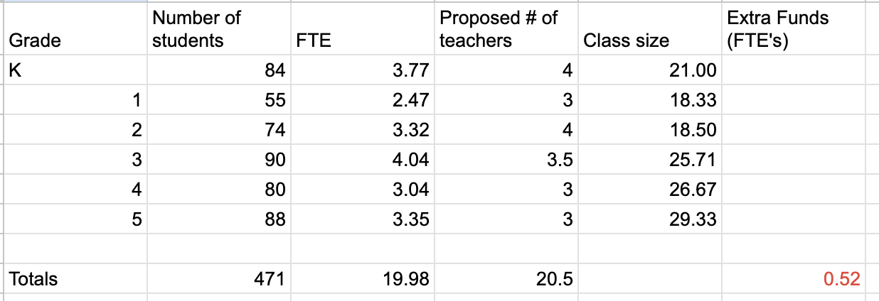

* + 1. Changes go into place in October (and retroactively for 3rd grade teacher)
    2. Kali Agy suggested grade level planning days (which would incur substitute teacher costs/$170 per teacher per day). We will revisit this in October as a follow up budget item.
    3. Mr. Walker also suggested subs to allow teachers to visit other classes and observe teaching. We will revisit this in October as a follow up budget item.
    4. Grade level team transition discussions will happen in January in order to plan and anticipate changes for the following year.
  1. Vote:
     1. Move Third grade teacher to 24 hours
     2. Move BA to FTE benefitted
     3. Move to add one hour per day to interventionists
     4. Motion by Jenny to approve, second ME Clark
        1. Unanimous approval by those present
  2. Vote:
     1. Principal Walker asked for approval to use cell tower funds as a discretionary fund for school/staff expenses (birthday gifts, incentives, etc.)
        1. Move to vote Shawn Walker, second Holly Uphold
        2. Unanimous approval by those present

1. Mr. Walker distributed Safe Walking Routes Plan, and invited feedback for the next meeting.
2. Closing  
   Adjourned 4:58 PM